Houston Flood Vulnerability
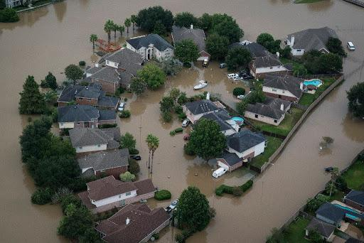]

Ahmed Alouddi, Erik Guzman, Gurvinder Bhogal, William Takahashi, Ediyanga Amos
160 Convent Ave, New York, NY 10031
AQUA LLC

TABLE OF CONTENTS
Introduction……………………………………………………………………..…………………3
- 1.1 Problem Statement………………………………………………………………….3-4
- 1.2 Background…………………………………………………………………………....4
- 1.3 Needs statement……………………………………………………………………..4-5
- 1.4 Objective……………………….….…….…………………………………………....5
Proposed Technical Approach……………………………………………………………..……5-6
- 2.1 requirements…………………………………………………………………………...6
- 2.2 architecture design……………………………………………………………..……6-7
- 2.3 implementation design……………………………………………………………....7-8
- 2.4 quality assurance plan…………………………………………………...…………….8
Expected project results……………………………………………………………………...….8-9
- 3.1 measure of success…………………………………………………………………….9
- 3.2 costs………………………………………………………………………………..9-10
Schedule………………………………………………………………………………………….10
References………………………………………………………………………………………..11

- Introduction
Floods have been a huge problem in many places causing calamity and casualties. Floods are caused in various ways such as hurricanes, heavy rainfall, or the inundation of rivers. Many states use many different methods to prevent as many casualties as possible by creating temporary shelters, rescue points, and rescue teams to rescue those who were caught in the flood. A few years ago in 2017, Hurricane Harvey a category 4 hurricane hit Houston Texas, and damaged most of the city causing many casualties. The hurricane brought tons of heavy rainfall causing a huge flood to rise to 5 feet. Many people were stranded on the streets during the storm and others were in temporary shelters such as churches and local stores. These shelters were on ground level which is not safe when trying to escape a flood. Many people were not able to reach shelters for safety or high grounds. Houston had rescue teams to go and pull out those stranded in the storm. Houston is the biggest city in Texas and the 4th largest in the U.S. and with a population of 2 million. Hurricane Harvey dropped years of heavy rainfall in a day and caused about 125 billion dollars in damage.

1.1. Problem Statement
Floods not only put people in extreme danger but they also cause billions of dollars in damage. People with more than one story homes are safer from flooding than those who have one-story homes. However, the problem is that not everyone has that type of luxury. People who are in danger should at least be able to go to a safe place where they won’t be reached by the flood. Around three years ago, almost 32,000 people were forced into temporary shelter homes during Hurricane Harvey alone. Some temporary shelters were not even flood-proof. Also, 17,000 other people had to be rescued because they could not make it to safety. For many people, recovery still hasn’t ended to this day. With that being said, people need a trustworthy method of getting to safety when needed most.

1.2. Background
Flooding in Houston, Texas has always been a problem. Every other year there is a flood problem. On the Texas coast, there are intense rainfall events which cause flooding along the bayous, rivers, creeks, and roadways. Not to mention, hurricanes push a huge mass amount of water from the oceans into the city. Many of these events put people and their property in danger. Since the flooding in Houston is basically a routine, there are always reports of floods somewhere in Houston. In 1937, dams and reservoirs were built after facing a couple of deadly floods while Houston was still growing. One of the floods caused the water to raise over 50 feet. Throughout the past 60 years, the dams and reservoirs controlled the floods and prevented any major damage including those from multiple hurricanes; Audrey (1957), Carla (1961), and Alicia (1983). However, in the 21st century, everything went downhill. In 2001, a tropical storm, Alison, caused 23 fatalities, over 70,000 homes damaged, and 95,000 vehicles damaged as well. Then Hurricane Harvey struck, which was way more devastating. An estimated 5 trillion gallons of water fell on top of Houston. No type of flood control can handle this much water. Ensuring safety for the people is very important especially to those who live in these areas.

1.3. Needs statement
Natural disasters cause a huge amount of casualties and panic to the people of Houston. Many people who are confused during the hurricane and don’t know where to reach a shelter become stranded in the storm. This causes many people to become stranded because they are not able to find a shelter that is high ground. Around 17,000 people had to be rescued during the storm because they were either stranded or still looking for safety. These temporary shelters provided may not be able to maintain the people’s safety. For people not to worry about their safety in shelters, we will be building permanent flood-resistant shelters to make people have fewer worries and less panic.

1.4. Objective
Our team is working on constructing a permanent flood-resistant shelter across Houston. These shelters will have multiple floors and will be placed around Houston neighborhoods. These shelters will be built within neighborhoods to make access to shelters easier, faster, and more efficient during floods. The shelters will be built with a strong base and foundation that will be able to withstand floods, especially those that are caused by hurricanes or storms. These shelters will be high enough for people to know where they are during floods. In doing this, our team hopes to have fewer to zero people stranded in storms and increase the safety for people.

2. Proposed Technical Approach
We will apply for a flood infrastructure fund through the Texas water board program. We will check on the eligibility, find the related category, fill out, and submit the related application together with this project proposal. Hopefully, we will get the fund from one or more eligible programs. After getting authorization from the mayor to build these shelters, we will go through the city in the first 6 months to plan out where each shelter will be and check out to see if the space to build the shelter is good enough in the area. After going through each neighborhood there will be 2-4 shelters within each neighborhood so people can access shelters at a faster pace and reach safety. Houston has an estimated population of 2 million residents which means our team will have to create a lot more shelters because not many people own two-story houses. These shelters will be built on a strong foundation and strong materials to make them resistant to flood. These buildings will be around 18 feet high and will have a capacity of 200-300 people.

2.1 Requirements
Firstly, a large amount of property needs to be acquired to build a shelter home. We will need a flood-resistant material to construct a shelter. The National Flood Insurance Program will help assist in protecting our structure. We will need concrete, both precast, and cast in place. Concrete is a waterproof material. It is highly resistant to flood damage, including damage caused by moving water. Concrete can survive the effects of wetting and drying, along with being able to be cleaned from harmful pollutants contained within the flood. This will reduce the cost of excess repair and facilitate faster recovery. Concrete can be used both outdoors and indoors as well. For fasteners, only stainless steel fasteners will be used. These fasteners include nails, screws, bolts, and anchors. The same material will also go for connectors.

2.2. Architecture Design
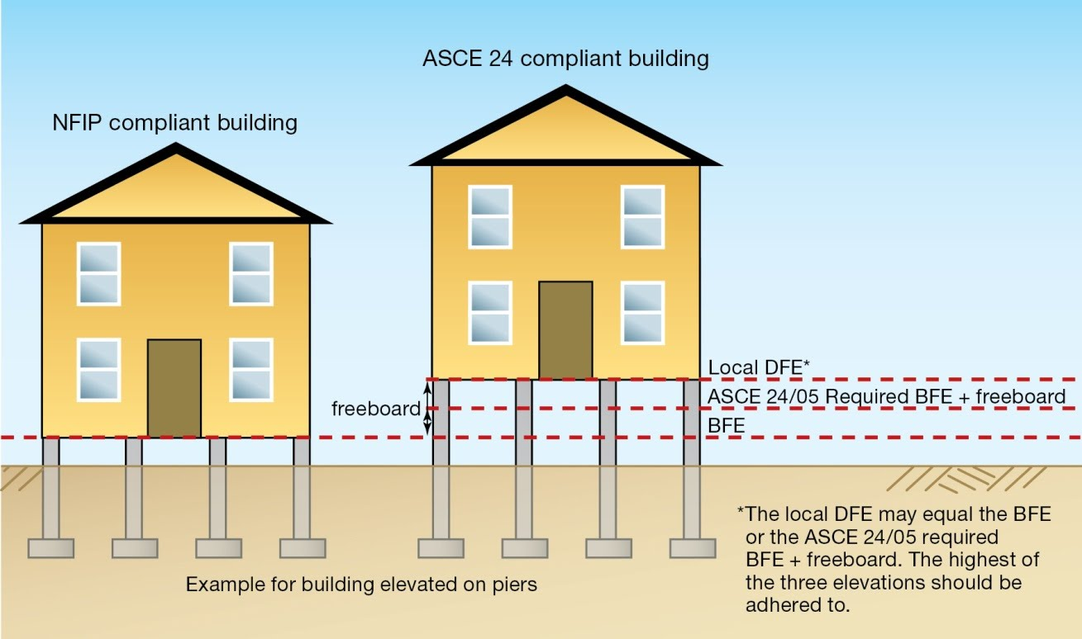
The most important part of the design is to elevate the lowest floor of the shelter to be above the base flood elevation (BFE). All of the construction below the BFE is susceptible to flooding. This precaution will still be taken regardless of using flood-resistant material. Even if the lowest level of the building will be well above BFE, it will be used only for storage or parking vehicles. This shelter home has to be a multi-story apartment type building for people that have to live there in case of home wreckage. It will be not too different from a regular apartment building.

2.3. Implementation Design
We will begin constructing the stilts at least 4 feet above ground level and then begin building the interior and exterior with concrete and steel. Also, there will be pillars to make the building stronger. There will be 3 floors and each floor will have a capacity of 50 to 100 people. The interior will have foam insulation to ensure the water doesn’t come through. The front of the building will have stairs in order for people to enter the building. The needs for people to be able to stay in this situation has to be granted as well such as food, clothing, water supply, and many rooms with beds will have to be made in an efficient method. Methods of transportation are already implemented in Houston Texas. There are rescue teams already available to those who need it in Houston Texas. Also, helicopters will be the major way of transportation, but boats have to be available as well when needed.
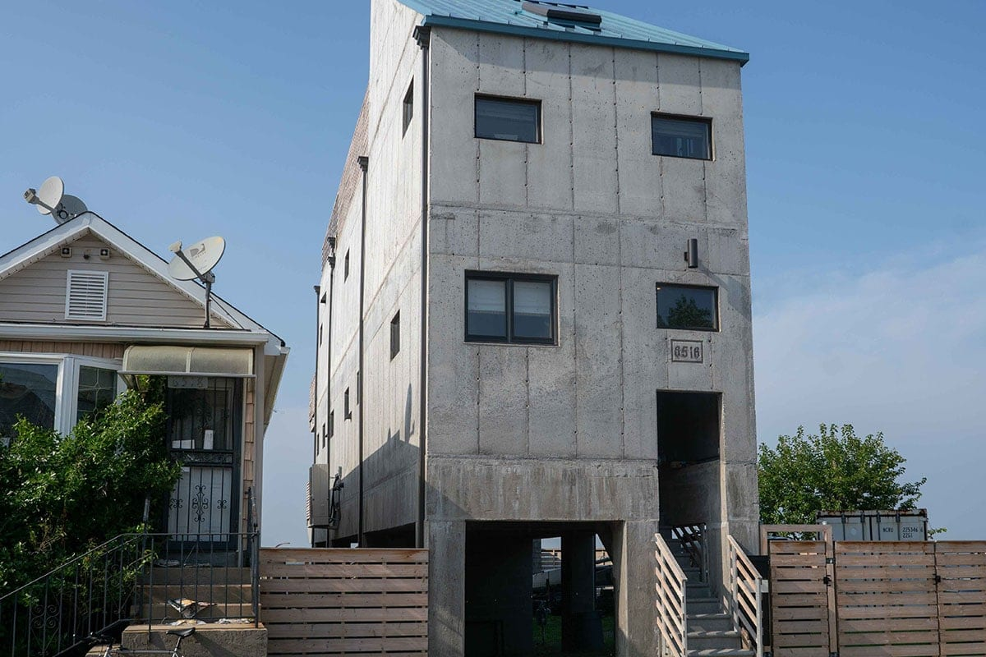

2.4. Quality Assurance Plan
In order for people to reach safety quicker during floods, we need to construct flood-resistant shelters in areas of Houston neighborhoods. These shelters would provide food, water, and other supplies during the floods so people can temporarily stay there until the flood has been cleared and they are able to get back to their homes. The structure will act as a firewall against floods. It will be able to withstand the forces of the water and the toxins from the flood can be easily cleaned and restored due to the material we will be using.

3. Expected Project Results
- We expect this project to be a strong structural building that will withstand floods and protect people from floods.
- We expect the number of casualties including death, injuries, and missing people to drop at a high rate.
- We expect this project to be a backup for people that lose their homes.
- We expect these shelter homes to be a temporary home for the people that lose their original ones so that they have a place to safely live in.

3.1 Measure of Success
- Our shelter homes will be made of flood-resistant material that will be easily restored and renovated which will keep the shelter in service for a long time.
- People can be there with their loved ones being safe
- People will be able to communicate with their loved ones and the internet will be provided to them as well.
- People can live there until they are recovered from their damaged homes.

3.2 Costs
The construction of these buildings will be three stories and will consume 6,000 sq/ft of land. The construction will be done by an estimated 60 total workers. It will take 6-8 months to complete the construction site. The land is fairly cheap, but the construction will cost around $3.6 million dollars. There will be just enough utilities and supplies inside the building. A total of 15 staff members will be working for their designated area on the site. Each housing floor will have 5 staff members. But, they won’t be working year-round, only when the shelter home will be under usage during flood emergencies. Four certified transporters will also be available when needed during these times. The table below is a breakdown of the estimated production and development costs for the project.

Production Costs
Description | Unit per each shelter home | Total Project Cost per each shelter home
Land | $4,293 per acre | $592
Workers | $17 per worker (60) | $86,700
Manufacturing Space | 3-floor building | $3.6 million
Utilities | Supplies & Needs | $200,000
Staff Members | 15 staff members | $21/hr per staff member
Total Costs |  | $3,917,292

4. Schedule
Date | Tasks
01/01/21 | Request authority from mayor and request funds
02/05/21 - 08/05/21 | Look around Houston and check spots that will allow people will be able to access the shelters easier and faster
08/06/21 - 04/06/22 | Receive the equipment and structures needed and begin constructing the shelters in the designated areas
04/10/22 - 04/21/22 | The shelters are checked to make sure they are well constructed and there are no errors so that we can ensure the buildings are safe.
05/20/22 | Supplies and equipment are placed inside the shelters

References
- Average price per acre for land outside of Houston Archives. (2020). Retrieved November 30, 2020, from https://t2ranches.com/tag/average-price-per-acre-for-land-outside-of-houston/
- Flood Infrastructure Fund (FIF). (2020). Retrieved December 01, 2020, from https://www.twdb.texas.gov/financial/programs/FIF/index.asp
- FLOOD RETROFITTING AND RECONSTRUCTION PROJECTS IN THE SANDY-IMPACTED AREAS. (2013). Retrieved November 30, 2020, from https://www.sites.google.com/site/metropolitanforensics/flood-retrofitting-and-reconstruction-projects-in-the-sandy-impacted-areas?tmpl=%2Fsystem%2Fapp%2Ftemplates%2Fprint%2F
- Floods. (2020). Retrieved November 30, 2020, from https://www.ready.gov/floods
- Fontan, J. (2020, June 03). Flood Proof House Design · Fontan Architecture. Retrieved November 30, 2020, from https://fontanarchitecture.com/flood-proof-house-design-ideas/

- Protecting Against Flood Damage. (n.d.). Retrieved November 30, 2020, from https://www.hgtv.com/design/remodel/mechanical-systems/protecting-against-flood-damage
- Resnick, B. (2017, August 29). Why Houston's flooding got so bad, according to storm experts. Retrieved November 30, 2020, from https://www.vox.com/science-and-health/2017/8/29/16216568/hurricane-havery-houston-flooding-experts
- Squerciati, J. (2018). FIVE PROMINENT FLOOD RESISTANT BUILDING TECHNIQUES. Retrieved November 30, 2020, from https://www.dewberry.com/news/blog/post/blog/2018/10/18/five-prominent-flood-resistant-building-techniques

- https://plummersdisposal.com/wp-content/uploads/2018/04/new-loss_revenu-Avg_numbworkers_construction_site.pdf

Audience Analysis sheet 1

Reader’s Name: Sylvester Turner

Reader’s Job Title: Mayor

Kind of Reader: Primary Reader

Education: graduated from the University of Houston and earned a law degree at Harvard Law School

Professional Experience: American Attorney, Lecturer at South Texas College of Law and University of Houston Law School.

Job Responsibilities: Administrates the city’s annual Expenses, Budgets, and financial plan. Managing the city relations with federal-local governing entities.

Personal Characteristics: Busy and has to manage the city but understand that the proposal will help lessen casualties during floods

Cultural Characteristics: He is a Baptist and attends church. Religious

Attitude towards the Writer: Trusting and willing to listen to the proposal

Attitude towards the Subject: Approves giving permission and is interested in its results

Expectation about the Subject: Hope to see results and benefits
Expectation about the Document: Provides information on the shelters and is well detailed on what the shelter is going to look like

Reasons for reading the Document: To create flood-resistant shelters within Houston so there can be fewer people stranded and fewer casualties

Reading Skills: Excellent

Reader’s Physical Environment: At his office

Audience Analysis sheet 2

Reader Name: Texas Water development board, flood infrastructure fund(FIF) application committees
Reader Job: Funding application committees board members
Education: bachelor degree
Experience: Board managements
Job scope: managing city flood affairs, reviewing applications, approve funds
Personality: Easy going
Cultural Characteristics: interested in politics, civil ideas
Attitude Toward the Writer: probably interested
Attitude Toward the Subject: probably interested
Expectations About the Subject: flood sustaining housing funding applications
Expectations About the Document: hopefully the board will review and consider the application
Reasons for Reading the Document: To fund the flood prevention housing project
Ways of Reading the Document: skim reading and find supporting documents if possible
Reading Skills: professional
Reader Physical Environment: an office or home office

Audience Analysis sheet 3
Reader Name: U.S Department of Labor, Houston Texas
Reader Job: Provision of workers to be essential parts of the Project
Education: bachelor degree
Experience: Provision and certification of potential workers
Job scope: referral for job seekers and increasing chances for profitable employment
Personality: Easy going
Cultural Characteristics: Increasing the number of employed people
Attitude Toward the Writer: probably interested
Attitude Toward the Subject: probably interested
Expectations About the Subject: Possible problem that can create jobs for unemployed
Expectations About the Document: Review and action taken towards our application
Reasons for Reading the Document: Support a project that could create jobs
Ways of Reading the Document: skim reading and find supporting documents if possible
Reading Skills: professional
Reader Physical Environment: an office or home office

Ahmed Alouddi - Reflection
This engineering proposal was very interesting and required a lot of research and effort. Writing a proposal was a first for me and we had to work on it with a group. This became a little bit difficult since everything was remote. Our group had different schedules so we had to choose times that were convenient for all of us. An engineering proposal is a document that details a plan to solve a problem and to persuade the reader to support the plan. My group decided to do a plan revolving around floods. We decided to focus our topic on Houston Texas as it just had a hurricane in 2017 that poured tons of water on Houston. We brainstormed our ideas of providing a solution to help during storms. We had plenty of ideas but most of them were already implemented in the city. After receiving feedback from the professor we did a little bit more research and came up with creating permanent flood-resistant shelters that will have a capacity of 200 - 300 people throughout Houston neighborhoods. The benefits of creating these shelters around neighborhoods in Houston is to allow people to enter the shelters if their house or building won't be able to handle the flood.
The purpose of the assignment is to persuade the Mayor and the readers to support our plan in creating permanent flood-resistant shelters. Right now there are only temporary shelters such as local churches and stores that are on ground level which can be unsafe during a flood. We are trying to create these shelters that are safe and resistant to the flood around Houston neighborhoods.
The exigence of this assignment comes after Hurricane Harvey in 2017 when there were around 17,000 people that were stranded and had to be rescued because they were not able to reach a shelter or safety near their area. This is a huge problem and could have caused people to die.
The genre of this assignment is an engineering proposal. In the engineering proposal, we will present the current problem and our plan to fix and the results that will come from establishing this plan.
The audience of this assignment is the Mayor, the Department of Labor, the Texas water board fund program, and the residents of Houston. We need the mayor to give us approval of our plan and the Texas Water Development Board to accept our proposal and give us the funding.
The media of this assignment is digital and presentation. Throughout the proposal, we had to do all our work online and discuss our proposal through social media. We will be presenting our proposal to the entire through zoom.
My stance towards this topic is that something needed to be done about the situations that floods are causing and to be able to provide safety to people so fewer people can be stranded during storms.
This assignment meets course learning outcomes 2, 4, 6, 7. It meets number 2 because in the assignment we had to do a lot of research and put it in our proposal which required a lot of revision and reading throughout the proposal. It meets learning outcome number 4 because as a group we had to peer review each other’s work and as a group, we conducted this proposal and helped and corrected each other throughout the way. It meets learning outcome number 6 because we were able to present the group stance into the proposal. It meets learning outcome 7 because we used many sources and did a lot of research to find a website that will help us with our proposal. We also used images in order to show examples of how the shelter will look like after it's built to show the reader and persuade them a bit more. In this group, I was the person who helped out others when needed help, pushed my group to begin the project, and reminded my group to continue working on the project and how to do it if they needed help.

William Takahashi- Reflection

We submit a project plan together with a fund application to the Texas Water development board, flood infrastructure fund(FIF) application committees to approve our application. We wrote about why it is an issue, the background, and what could be done to improve the situation. We made an estimated plan for each step that needed to be done, including planning, designing, budgets, and detailed housing plans. We apply for funds based on sustainable infrastructure, and we think our project would be qualified for the flood infrastructure fund.
We then listed a few potential problems and possible solutions. I hope the water board committee members can review the application and hopefully consider funding our project. I believe our project is cost-effective, reliable, and can be built in a timely manner. Our 3 story special housing can serve 200~300 people at a time.
This reflection paper is to summarize the issue and serve as a guideline for reading through our project. Thank you!

Erik Guzman- Reflection
This engineering proposal was very interesting. This was honestly my first time writing one and I actually enjoyed it. Since I like learning new things, this helped me learn many new things. Working as a team was very much fun. Although I will be honest this was a bit difficult because of the problems that we kept facing like money issues and where the funding might have come from and what not. It makes me happy to know that I am trying to ensure the safety of my people's lives. No, I may not know these people, however, we are all from the same race, the human race. The purpose of this proposal was to convince the mayor and gain funds from the texas water board program so we can ensure the safety of the people of Houston Texas. The exigence is the fact that Houston texas receives so many floods and so many casualties we decided to help Houston texas. The genre is an engineering proposal. The audience is the mayor of texas, the department of labor, the texas water board program, and the residents of Houston. The media is digital, we worked through social media and did research strictly online due to the current situation. My stance towards this proposal is straight forward. I want to ensure the safety of those who live in Houston Texas and get hit by floods due to natural disasters.

Reflection Paper ( Gurvinder Bhogal)
Our role in this project was to propose a problem related to natural disasters and develop a solution for a specific problem. We chose floods as the natural disaster and we based them on the city of Houston. This engineering proposal project required a lot of time and a lot of research. Personally, I have never done a project like this before. Due to being it my first time, I was worried that we won’t be able to complete this assignment on time because we faced a wall many times throughout the project and even doubted the topic we had chosen for our proposal. However, we were able to research as a group and find our answers to our problems. Another challenge we faced was communication. Since, we are working remotely and we all have different schedules, it was hard finding the right time that was convenient for all of us at the same time. But, working as a group helped us get through this project more easily than working on it alone.
The genre of this assignment is a proposal. A proposal is a document used to persuade the reader to consider, fund, or support an idea that the writer wants to pursue. Our project follows the working of a proposal because it describes a dangerous issue of floods which can cause many casualties and we propose a solution to this problem. Our proposal also includes the process and the needs to facilitate our solution.
The audience of this proposal is primarily the mayor of Houston, Sylvester Turner, and the Department of Labor. In our proposal, we seek to request the mayor to give us permission to facilitate our plan and blueprint. We also hope to receive help from the labor department to provide us with workers for the construction. Other viewers of our project maybe the people who are interested and supportive in our project and may want to help contribute towards it, such as by funding and investing, or even helping us quicken the process.
Our purpose of this proposal is to inform the readers that our plan is a great step towards keeping the communities of Houston safe in an efficient and reliable manner. We want to persuade them to help us follow through with our goals and persuade them to provide us with funding as well. My stance on this subject is that many people in Houston face many casualties during times of flood. Not everyone has a safe home where they can go upstairs to the second floor so that they don’t aren’t in the flood. People need to be safe and be able to rely on a second option where they know they will be safe along with their families and loved ones. We cannot always prevent homes from being wrecked, but we can assist the people to be safe. I believe that this project is essential to the well-being of the people of Houston since they were devastated by Hurricane Harvey three years ago.
The media of this project is multimodal because we use a document to write a proposal, which can be printed out on paper anytime and we also use a PowerPoint presentation to present our project to the class online as well via zoom. Before we finalized our product, we submitted our drafts on blackboard so that our peers can leave reviews and comments about our projects.
The exigence of this assignment is devastation to the people who have suffered from Hurricane Harvey. This hurricane happened three years ago but there are still people who still haven’t recovered from it up to this day.
The learning outcomes I have learned in this project are 4, 5, and 7. The assignment meets outcome number 4 because we worked in groups over the course of this assignment. We also had other classmates to go over our project for review to make it better. It meets number 5 because the genre of this assignment is a proposal and it meets the requirements to be in the media of multimodal. It also meets number 7 because we did a lot of research using the internet and articles that assisted us in getting the information and the data we needed.
Ediyanga Amos Proposal Reflection Paper
As a potential Mechanical Engineer, there are essential skills that I would need to learn to be effective in this field, with writing being an important part of this process. Engineering Proposals are essential documents that I now understand as a result of learning. However, the learning process was not as easy as it was portrayed. A bulk of the learning was done through a group assignment format. Due to the online learning situation, I knew it would be a very challenging process to go through as regular communication through mobile devices would be essential. I significantly improved my communication skills through this process and gained a better understanding of teamwork.
The engineering proposal focuses on people's safety during and after flooding disasters in Houston, Texas. Knowing we had much work to cover, all the group members stepped up to take on different workload parts. Roles were not designated through a meeting. I was heavily involved in the essential aspects of the engineering proposal and PowerPoint and general editing of statements that could be easily misconstrued. However, I feel I did not do a nearly perfect job at the latter.
Ahmed, Erik Gurvinder, and Williams did an almost equal and excellent work throughout the process without a designated role. Since we did not have designated roles, everyone worked on everything, ensuring no room pressure for anyone to deliver a section of the documents if they were unable to complete it. The genre for the project designated is a proposal. The proposal's purpose was to gain government authorization from Houston to start operations and raise financial support to fund the project. The paper's audience includes The Department of Labor, Residence of Houston, Texas, The Mayor of Texas, and the Texas Water Development and Board Program. The exigence for the proposal is the current state of safety for people who experience flooding disaster and how the situation needs to improve. The media used for the proposal document is printed media. However, it would be circulated in a digital format. The presentation aspect is also in digital format that would be used in a presentation format.
Overall, I believe that as a group, we did a great job of working together. Through our combined experience, we have been able to learn and understand Engineering Proposals properly as well as prepare an example of one.

