Sustainable Housing

William Takahashi

Table of Contents
Technical Description-----------------------------------------------------------------------------------------3
Proposal---------------------------------------------------------------------------------------------------------7
- Summary/Synopsis------------------------------------------------------------------------------7
- Introduction--------------------------------------------------------------------------------------7
- Problems Statement-----------------------------------------------------------------------------8
- Needs Statement--------------------------------------------------------------------------------10
- Technical----------------------------------------------------------------------------------------11
- Financing---------------------------------------------------------------------------------------12
- Materials----------------------------------------------------------------------------------------13
- Architecture Design---------------------------------------------------------------------------14
- Quality Assurance------------------------------------------------------------------------------15
Schedule-------------------------------------------------------------------------------------------------------16
Audience Analysis-------------------------------------------------------------------------------------------19
References----------------------------------------------------------------------------------------------------21

Technical Description
According to a report, more than 300,000 people were killed, several hundred thousand were injured and nearly 1.5 million were left homeless when the 7.1 magnitude earthquake hit Haiti in 2010. There are a lot of issues raised after the disaster. One of the major issues is housing. How can we build sustainable housing at low cost, but fast speed? A few years earlier I learned about Shigeru Ban's cardboard technology. A technology that transforms recycled cardboard into strong sustainable materials. I think it may be a way of future architecture technology.
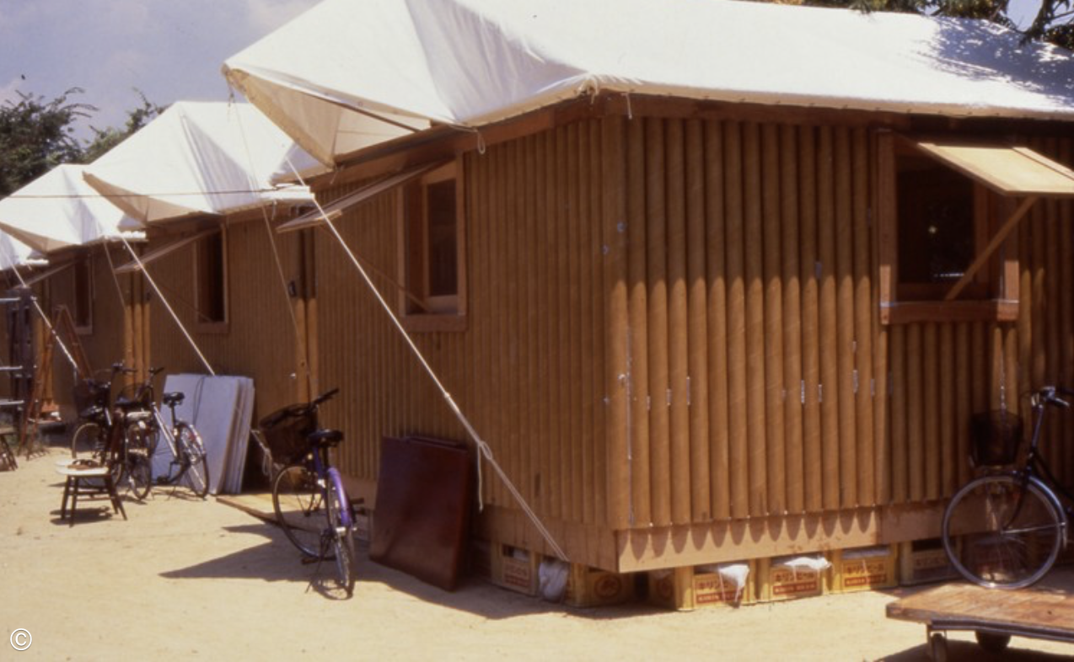

Summary/Synopsis:
The proposed technical project is to develop low cost sustainable housing that helps with disaster relief. The reason for the material is due to its extremely low cost compared to concrete and bricks. The technology relies on geometry and force distributions to make the building permanent or in some cases outlived many old existing architectures.
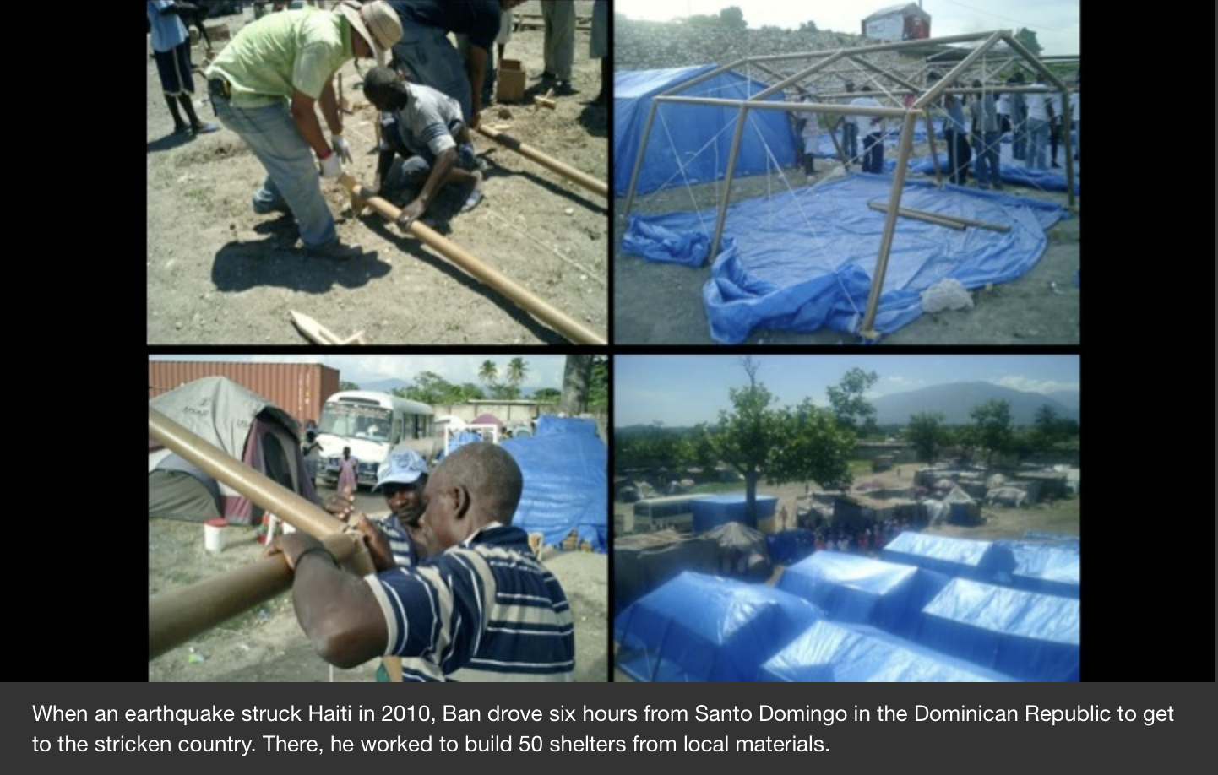
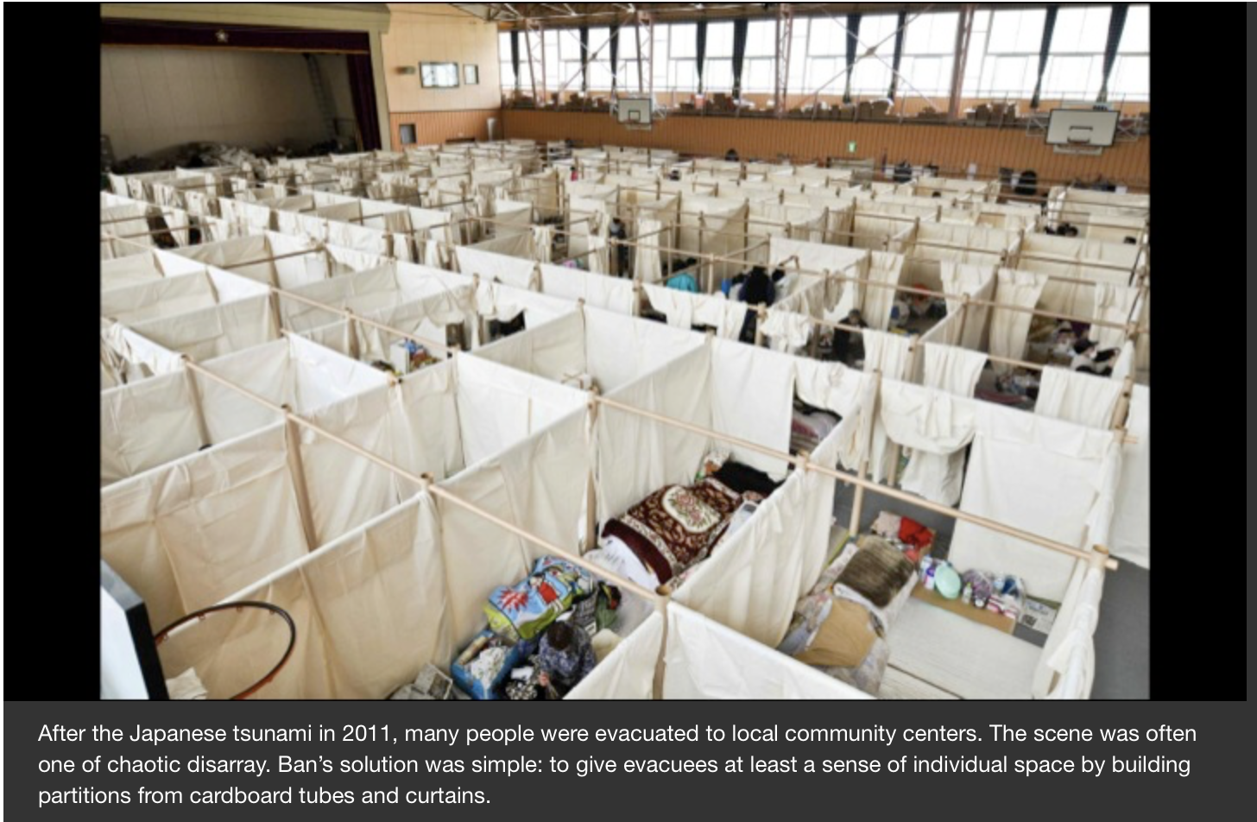
1. Introduction
What are some of the benefits of using Shigeru’s cardboard methods to create sustainable housing? According to his own profile and many testimonies:
The Characteristics of multistory temporary housing:
1) shorten the construction period by usage of existing containers
2) possible to build up tp 3 stories and to be build in narrow sites or slope lands
3) placing containers in a checkerboard pattern and create a open living space in between
4) excellent seismic performance
5)can be used as a permanent apartment

2. Problem Statement
Haiti is vulnerable to earthquakes and other natural disasters. There are many issues surrounding post earthquake rehabilitations. One of the major problems is the lack of housing. Building housing can be time consuming at extremely high cost. Therefore, sustainable cardboard housing may be a new way of solving the housing issue in disaster prone areas.

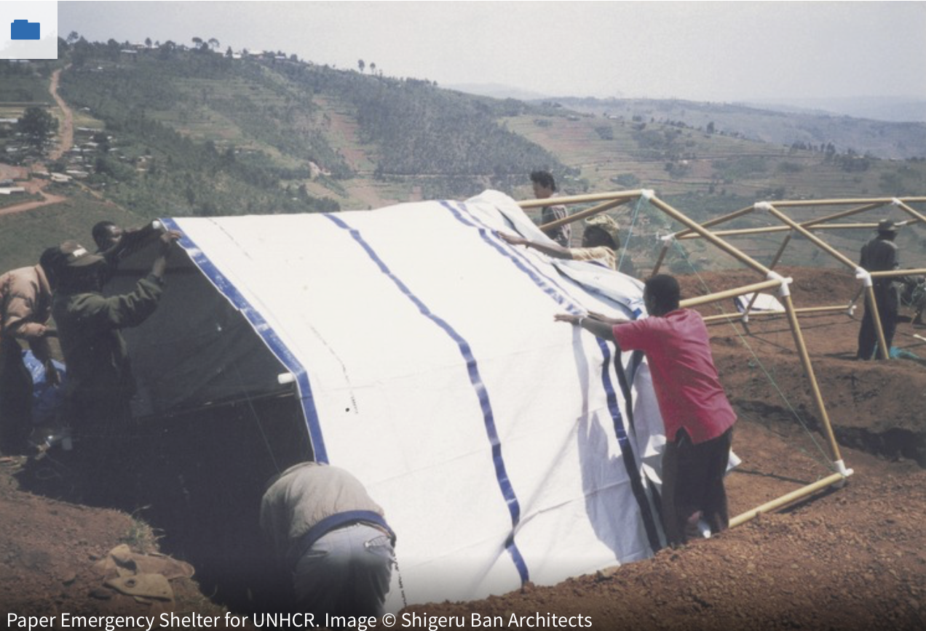
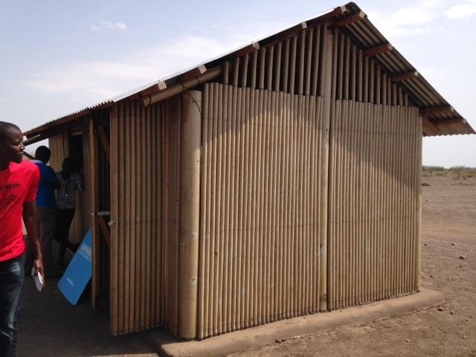

4. Needs Statement
On January 12, 2010, a 7.0-magnitude earthquake struck near the Haitian capital Port-au-Prince. The greatest damage to buildings was severe. 1.2 million people lost their homes and more than half a million people are taking refuge in the refuge hand-made tents that are not water-proofed. Shigeru Ban is collaborating with professors and students from Universidad Iberoamericana and Pontificia Universidad Catolica Madre y Maestra of the Dominican Republicand is building 50 shelters made of paper tubes and local materials for sustainable housing.

5. Proposed Technical Approach
The core of the construction is the cardboard tube. The tube must be very strong in order to last long or even serve as permanent housing material. With modern technology, the cardboard can resist fire, waterproof, and it is so easy to replace as an individual part as needed. The next step is the design of the architecture. Any architecture needs professional engineering designs to be able to hold the weight and last longer. We have partnered with Shigeru’s team and his past engineers in Haiti to make sure our construction meets the geometrical quality to last for a while. 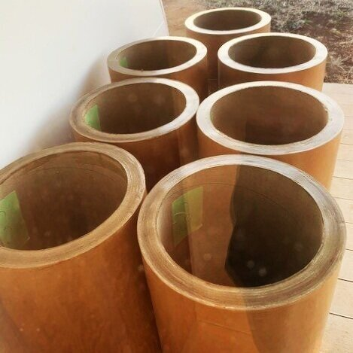
The design of the housing can range from single story to double story, or even large churches for special needs. There are occasionally larger buildings that can be built with such technology, such as schools and studios. The Housing contains 5 major layers. The bottom layer consists of bases to hold the building. Then the walls of the house are lined up with strong cardboard tubes. The circle can hold the most weight compared to square or other shapes, that’s why circular tubes are used in this design. The top layer of the house is once again lined up with strong cardboard tubes. The tube is water and fireproof. It can resist heavy wind as well.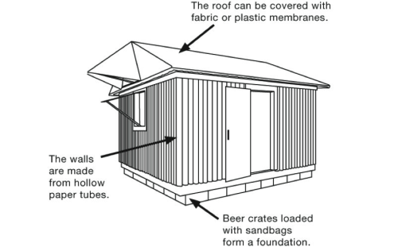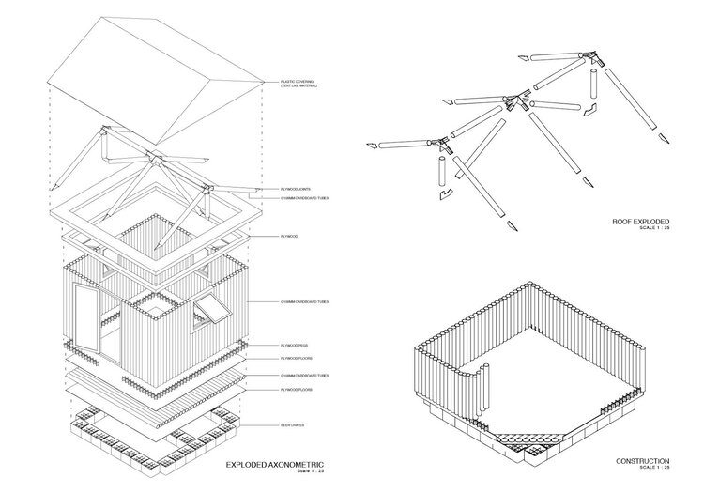
6. Financing
The project cost varies depending on the country. In some cases the cardboard material can be made from fresh recycled materials. The cost of materials for one 52 square meter unit is below $2000. Sometimes the money can be collected through donations or public fundings. The funding of the project is very flexible. Since the materials and designs are currently not in the competitive markets, the price can be flexible and easy to achieve. The projects have been gain reputation for quite a well and the demands for such projects are increasing.
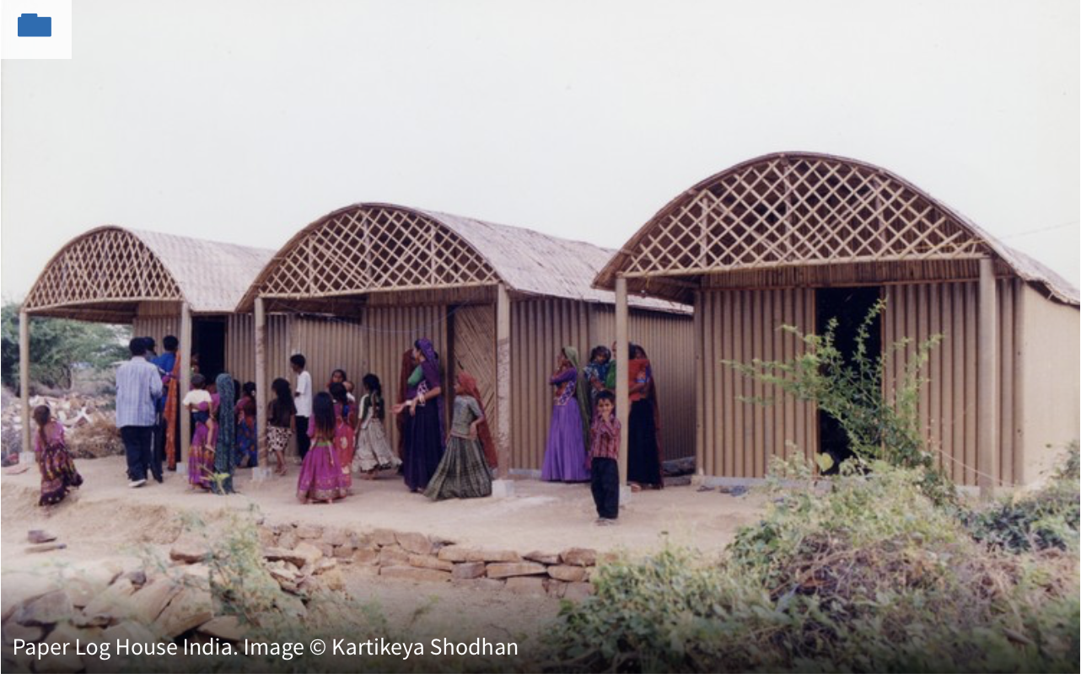
7. Materials
The main material of the building is the cardboard tube. It is the foundation of the construction.Cardboard tubes are so commonplace that we can find them everywhere. In a roll of toilet paper, in the packaging of the college diploma, in fireworks, and in the tissue and paper industries. And now, more and more, they can be found in unusual places, such as on the walls of houses and buildings. The material is part of modern life and is being produced for a multitude of industrial applications and consumer products. The vast majority are used as structural cores in winding operations. Immediately after manufacturing, paper, film or textiles are rolled directly onto cardboard tubes resulting in a stable roll that is easily stored and transported.According to research carried out by the architect Gabriela Barros from the Municipal University of São Caetano do Sul, because it is lightweight, it does not require very sturdy foundations, reducing construction time and cost. As the installation process is done using fittings and ties, it is easy to disassemble and reassemble. It's simple and quick installation means that it is not necessary that the workmanship is specialized. In addition, the tubular shape offers the possibility of embedding hydraulic and electrical systems and optimizes thermal and acoustic resistance (as a function of the air wall inside the tubes). Here is an example of a cardboard tube formed Church. It can be used as a permanent building as well.
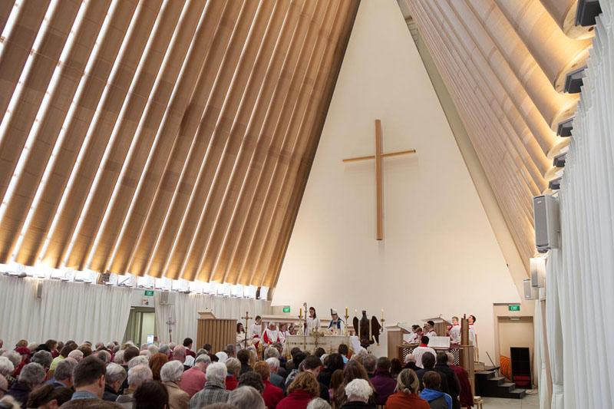
8. Architecture Design
First, we need temporary shelter designs before transferring people to individual sustainable houses. We need to build separated spaces that are easy to assemble and reassemble. 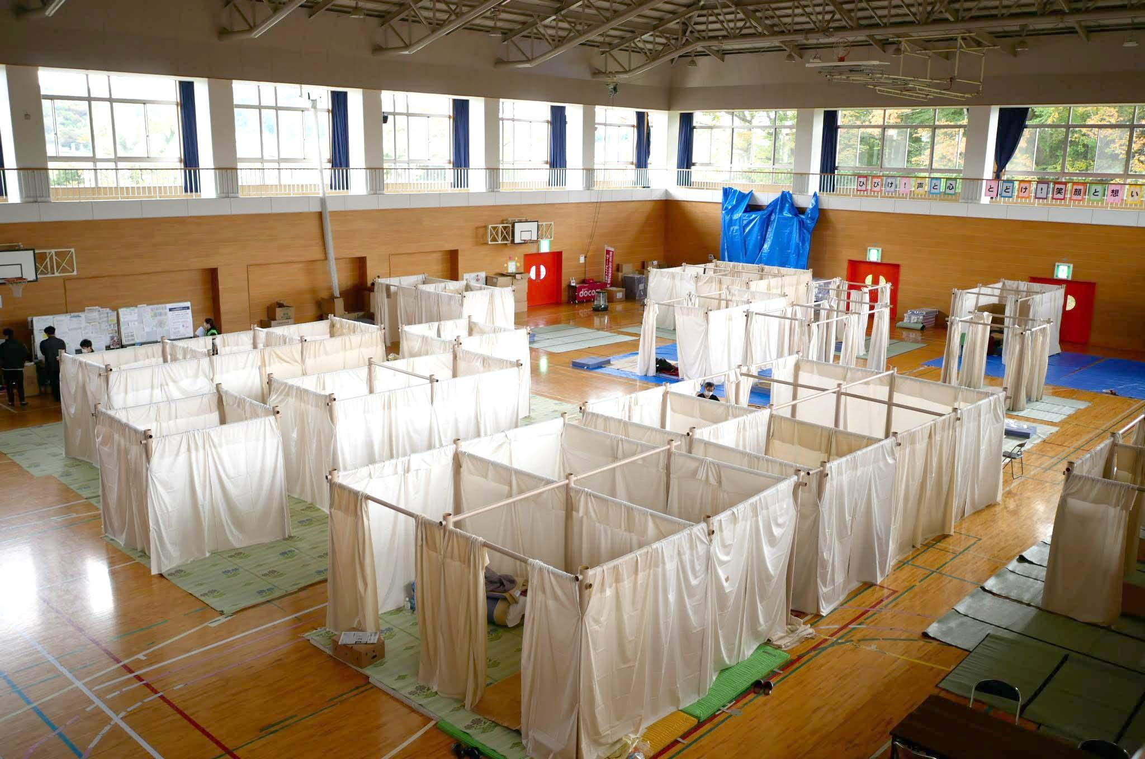
Then we need to design the housing according to geographic area, and calculate the amount of material needed for the constructions. We then assembled the houses according to the designs. Of course we need a professional constructors to supervise the whole process even though the assembling process isn’t complicated. 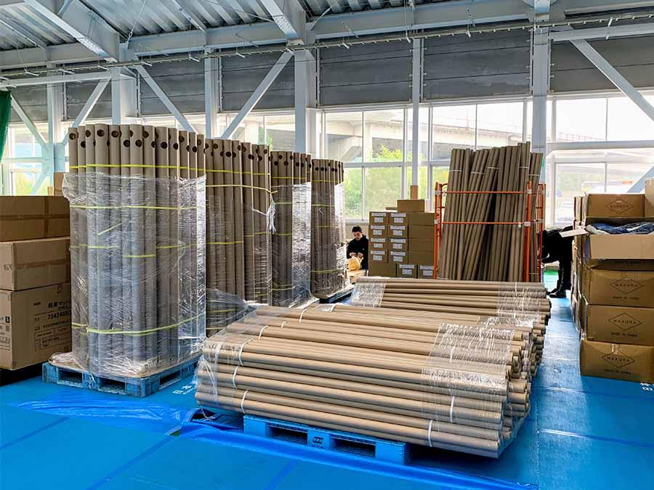

9. Quality Assurance
We will follow instructions from professional engineers supported by Shigeru’s groups. We will get every necessary license and permit for the construction. The most important part of the building is the cardboard tube, it must pass a required quality test before using. Also the design of the building must be specifically designed to make sure the distribution of forces will elongate the lifespan of the materials.

Schedule
schedule | Deadline
Gather building materials:  - cardboard constructions  - cardboard tubes/flats | Begin: May, 2020  End: June, 2020
Phase 1: design and testing with modes | Begin : June, 2020
Phase 2: Full construction of homes | Begin: July, 2020
testing each joints to make sure its quality | End: december, 2020
Gather feedbacks from inhabitants and employees | Start:january,2021

Audience Profile Sheet
Reader's Name:
President Jovenel Moise
Reader's Job Title:
president
Kind of Reader: | Primary X Secondary
Primary receiver
Reader’s Level of Education:
degree in political science
Reader’s Professional Experience:
Political managements
Reader’s Job Responsibilities:
running Haiti
Reader’s Personal Characteristics:
N/A
Reader’s Cultural Background:
N/A
Reader’s Attitude Toward the Writer (you):
unknown
Reader’s Stance
Supportive
Need other translations of this document to reach non-English speakers such as French
Reader’s Way of Reading the Document: | Skim it Yes Study it Yes  Read a portion of it Yes  Modify it and submit it to another reader ________
Reader’s Reading Skill:
High

References
ArchDaily 2020
https://www.archdaily.com/489255/the-humanitarian-works-of-shigeru-ban

Helen Water 2013
https://blog.ted.com/buildings-made-from-cardboard-tubes-a-gallery-of-shigeru-ban-architecture/
Morgan Marzo Jan, 2020
https://www.morganmarzo.com/researchinfo/2020/1/22/next-step-the-paper-tube
Eduardo Szusa 2019
https://www.archdaily.com/913567/cardboard-from-industrial-workhouse-to-shigeru-bans-master-material

