Health problems related to blue light glasses
ENGL 21007 research
William Takahashi

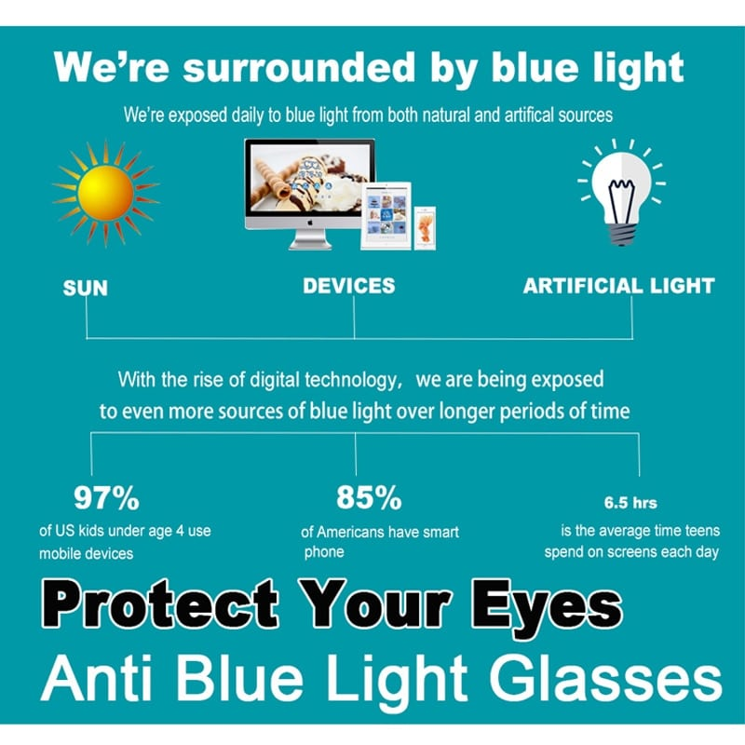

Table of Contents

Abstract………………………………………………………………………………………….. 3
Introduction……………………………………………………………………………………… 3
Methods…………………………………………………………………………………………..3
Materials…………………………………………………………………………………………..3
Charts…………………………………………………………………………………………..3

Abstract
Blue light is the collection of high-energy, visible light that neighbors ultraviolet — which we commonly block using sunglasses. Gadgets
can emit more blue light than any other part of the spectrum, and blue-light glasses companies say it can help relieve eye strain, headaches and blurry vision.

Introduction
Blue-screen or blue-light glasses can limit exposure to blue light. Additionally, blue light blocking glasses also include non-glare glasses. Blue light is found in cell phones, ipads, PCs lamps and even regular sunshine. Blue Light wavelength has been shown to potentially damage people’s eyes when exposed to it for longBluelight glasses can reduce the potential for eye damage and may improve symptoms of straining eyes. We are doing research to find out about this hypothesis.

Materials
- Blue light glasses
- Gaggets
- Documentations
- Timer/recorder
- Datasheet

Procedures
Find some volunteers and put them into groups. We will give them different gadgets to spend time with, then ask each group to write down their experiences. We measure their times spent on devices and the time they feel headaches, also frequencies of headaches at a certain period of times. Then we make a chart to compare datas.

Results

*First Week without blue light glasses*
Hours spent on the device | Group 1 | Group 2
1-2
3-4
5-6
7-8
9-10

*Second Week (Group 1 will receive blue light glasses and Group 2 will not receive blue light glasses)*
Hours spent on the device | Group 1 | Group 2
1-2
3-4
5-6
7-8
9-10

Legend: Headache = H , migraine = M , Eye Strain = E

Wait to discuss with our groups

Discussion

We are supposed to find out the time spent on devices and its effect due to blue light usages.
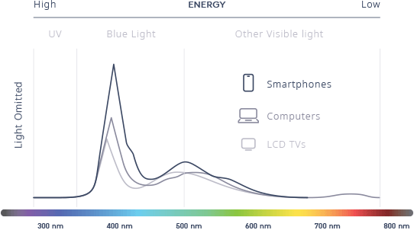

Conclusion

To be decided

References

Teddy Amendaba,Washington Post https://www.washingtonpost.com/lifestyle/wellness/blue-light-glasses-wont-save-you-from-digital-eyestrain/2020/03/04/eecbe98e-5356-11ea-b119-4faabac6674f_story.html

For Eyes coop, benefit of blue light glasseshttps://www.foreyes.com/blog/top-3-benefits-of-blue-screen-blue-light-glasses/

Audience Profile Sheet

Reader's Name:
Hospital Administration
Reader's Job Title:
Bellevue Hospital CEO
Kind of Reader: | Primary_X_____ Secondary______
Reader’s Level of Education: Medical Doctor
Reader’s Professional Experience:
More than 10 years
Reader’s Job Responsibilities:
Managing the hospital
Reader’s Personal Characteristics: | N/A
Reader’s Cultural Background: | N/A
Reader’s Attitude Toward the Writer (you): | N/A
Reader’s Attitude Toward the Position you’re applying to: | The reader is interested in saving money and this Lab Report provides ways for it
Reader’s Expectations for an employee in that position: N/A
Reader’s Expectations about the Résumé and Job Letter (as documents):N/A
Reader’s Way of Reading the Document: | Skim it _____ Study it ___X__  Read a portion of it ___ Which portion?  Modify it and submit it to another reader____
Reader’s Reading Skill: | Advanced
Reader's Physical Environment:
Office building
Adapted from Markel (7th Ed.), p. 88

Reflection Paper
We are discuss the effect of blue light glasses that could possibly reduce the negative effect of blue lights when using devices for so long. Our audiences are students, elderly, or regular library scholars.

